**Advance Excel Assignment 20**

1. Write a VBA code to select the cells from A5 to C10. Give it a name “Data Analytics” and fill the cells with the following cells “This is Excel VBA”

Ans. 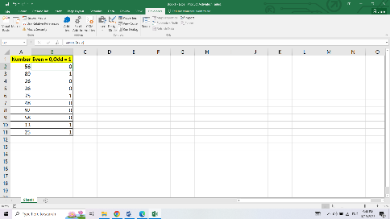

1. Use the above data and write a VBA code using the following statements to display in the next column if the number is odd or even

a. IF ELSE statement

b. Select Case statement

c. For Next Statement

Ans. 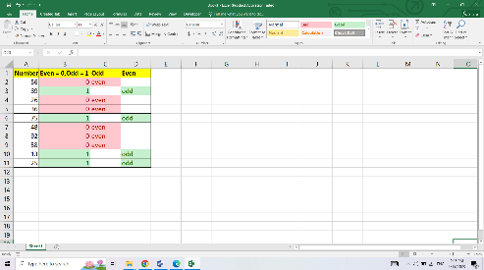

1. What are the types of errors that you usually see in VBA?

Ans. There are some common types of errors.

* Syntax Errors: These errors occur when the VBA code violates the correct syntax rules.
* Runtime Errors: These errors occur during the execution of the code. They can be caused by various reasons.
* Logic Errors: Logic errors occur when the code doesn't produce the expected results due to flaws in the program's logic.
* Object Errors: These errors occur when working with objects in Excel.
* Compilation Errors: Compilation errors occur when the code fails to compile due to issues.
* Overflow Errors: Overflow errors occur when a value exceeds the allowable range for the data type.
* Type Mismatch Errors: Type mismatch errors occur when there is an incompatible data type assignment or comparison.
* File Access Errors: These errors occur when there are issues accessing files, such as attempting to open a file that doesn't exist, insufficient permissions to access a file.

1. How do you handle Runtime errors in VBA?

Ans. Runtime errors are those that occur when the code is running. Run time errors will occur only when all the syntax and compile errors are being taken care of.

When a runtime error occurs, it will stop the code and show us the error dialog box. The message in the Run-time error dialog box is a little more helpful. It tries to explain the problem that can help we correct it.

We click on the Debug button, it will highlight the part of the code that is leading to the error. Click on Debug to highlight the code

We have corrected the error, we can click on the Run button in the toolbar (or press F5) to continue running the code from where it left. Or we can also click on the End button to come out of the code.

1. Write some good practices to be followed by VBA users for handling errors

Ans. When it comes to handling errors in VBA, following best practices can help improve the robustness and maintainability of your code.

* Enable Error Handling: Always enable error handling in your VBA code using the On Error statement. This ensures that runtime errors are captured and can be handled appropriately.
* Use Specific Error Handling: Implement specific error handling for anticipated errors. By using On Error Go To [label], you can direct the program flow to handle different types of errors individually, providing specific error messages or performing necessary actions.
* Include Generic Error Handling: In addition to specific error handling, include a generic error handler at the main entry points of your code (e.g., Sub Main ()) to catch any unexpected errors. This helps to prevent crashes and allows you to gracefully handle unexpected situations.
* Provide Clear and Informative Error Messages: When displaying error messages to users, make them informative and easy to understand. Include details such as the error number (Err. Number), error description (Err. Description), and any relevant contextual information to help users identify the cause of the error and take appropriate action.
* Log Errors: Consider logging errors to a log file or error tracking system for debugging and analysis purposes. Logging errors can help you understand the root cause of issues, track patterns, and improve the reliability of your VBA code.
* Handle Expected Errors Locally: When you anticipate an error in a specific section of code, handle the error locally rather than propagating it to a higher level. This allows you to provide immediate feedback or take corrective actions specific to that section, without disrupting the overall program flow.
* Validate Input Data: Before processing data, perform necessary validations to ensure data integrity and prevent potential errors. Validate user inputs, check for required conditions, and verify data types to avoid unexpected errors during the execution of your VBA code.
* Clean Up Resources: If your VBA code uses external resources (such as files, connections, or objects),make sure to properly release or close them in your error handling routines or when the code finishes executing. Failing to clean up resources can lead to memory leaks or other issues.
* Test Error Handling: Thoroughly test your error handling code to ensure it behaves as expected in various scenarios. Include test cases that cover both anticipated errors and unexpected errors. This helps uncover any issues in your error handling logic and allows you to refine and improve it.
* Document Error Handling: Document your error handling strategy within your code or in a separate documentation file. Describe the types of errors you handle, the specific error codes, and the actions taken in each case. This helps maintain code readability and facilitates future code maintenance.

1. What is UDF? Why are UDF’s used? Create a UDF to multiply 2 numbers in VBA

Ans. UDF stands for User-Defined Function. UDFs are custom functions that you can create in VBA to perform specific calculations or tasks. Unlike built-in functions in Excel (e.g., SUM, AVERAGE), UDFs allow you to extend Excel's functionality by implementing your own custom logic.

UDFs are used for various purposes, including:

* Custom Calculations: UDFs enable you to perform calculations that are not available through built-in functions. You can create complex mathematical operations, perform specialized data manipulations, or implement unique business logic.
* Automation: UDFs can automate repetitive tasks by encapsulating a series of actions into a single function. This allows you to streamline your workflow and improve efficiency.
* Data Validation: UDFs can be used to validate data entered into cells and provide custom error checking. You can create UDFs to validate data formats, check for specific conditions, or enforce business rules.
* Data Transformation: UDFs can be used to transform data from one format to another. For example, you can create a UDF to convert data from inches to centimeters or perform currency conversions.